**LAPORAN TUGAS**

**MATA KULIAH ALGORITMA DAN STRUKTUR DATA**

Dosen Pengampu : Farid Angga Pribadi, S.Kom, M.Kom.

**PERTEMUAN - 8 Normalisasi**



**Nama : M. Zidna Billah Faza**

**NIM : 2341760030**

**Prodi : D-IV Sistem Informasi Bisnis**

**JURUSAN TEKNOLOGI INFORMASI**

**POLITEKNIK NEGERI MALANG**

**2024**

**TUGAS 1**

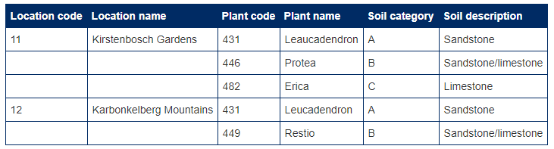

Tabel **1NF**

|  |  |  |  |  |  |
| --- | --- | --- | --- | --- | --- |
| **Location Code** | **Location Name** | **Plant Code** | **Plant Name** | **Soil Category** | **Soil Description** |
| 11 | Kirstenbosch Gardens | 431 | Leucadendron | A | Sandstone |
| 11 | Kirstenbosch Gardens | 446 | Protea | B | Sandstone / Limestone |
| 11 | Kirstenbosch Gardens | 482 | Erica | C | Limestone |
| 12 | Karbonkelberg Mountains | 431 | Leucadendron | A | Sandstone |
| 12 | Karbonkelberg Mountains | 449 | Restio | B | Sandstone / Limestone |

Tabel Location

|  |  |
| --- | --- |
| **Location Code** | **Location Name** |
| 11 | Kirstenbosch Gardens |
| 12 | Karbonkelberg Mountains |

Tabel Plant

|  |  |
| --- | --- |
| **Plant Code** | **Plant Name** |
| 431 | Leucadendron |
| 446 | Protea |
| 449 | Restio |
| 482 | Erica |

Tabel Soil

|  |  |
| --- | --- |
| **Soil Category** | **Soil Description** |
| A | Sandstone |
| B | Sandstone / Limestone |
| C | Limestone |

Tabel DetailSoil

|  |  |  |
| --- | --- | --- |
| **Location** | **Plant** | **Soil** |
| 11 | 431 | A |
| 11 | 446 | B |
| 11 | 482 | C |
| 12 | 431 | A |
| 12 | 449 | B |

**TUGAS 2**

|  |  |  |  |  |
| --- | --- | --- | --- | --- |
| **NIP** | **Nama** | **Jabatan** | **Keahlian** | **Lama Kerja** |
| 156107 | Rangga | Analis Senior | Java | 6 |
|  |  |  | Oracle | 1 |
| 156109 | Maura | Analis Junior | Java | 2 |
|  |  |  | C++ | 2 |
| 156120 | Cinta | Programmer | Dbase | 3 |
|  |  |  | Sybase | 1 |
|  |  |  | Java | 1 |

1 NF

|  |  |  |  |  |
| --- | --- | --- | --- | --- |
| **NIP** | **Nama** | **Jabatan** | **Keahlian** | **Lama Kerja** |
| 156107 | Rangga | Analisi Senior | Java | 6 |
| 156107 | Rangga | Analisi Senior | Oracle | 1 |
| 156109 | Maura | Analisi Senior | Java | 2 |
| 156109 | Maura | Analisi Senior | C++ | 2 |
| 156120 | Cinta | Programmer | Dbase | 3 |
| 156120 | Cinta | Programmer | Skybase | 1 |
| 156120 | Cinta | Programmer | Java | 1 |

2 NF

|  |  |  |
| --- | --- | --- |
| **NIP** | **Nama** | **Jabatan** |
| 156107 | Rangga | Analis Senior |
| 156109 | Maura | Analis Senior |
| 156120 | Cinta | Programmer |

|  |  |
| --- | --- |
| **Keahlian** | **NamaKeahlian** |
| 1 | Java |
| 2 | Oracle |
| 3 | C++ |
| 4 | Dbase |
| 5 | Sybase |

|  |  |  |
| --- | --- | --- |
| **NIP** | **Keahlian** | **Lama Kerja** |
| 156107 | 1 | 6 |
| 156107 | 2 | 1 |
| 156109 | 1 | 2 |
| 156109 | 3 | 2 |
| 156120 | 4 | 3 |
| 156120 | 5 | 1 |
| 156120 | 1 | 1 |

TUGAS 3

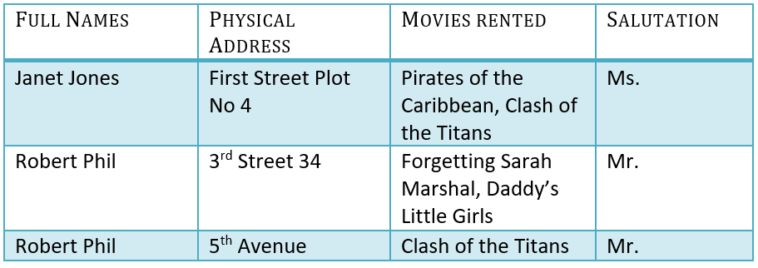

1 NF

|  |  |  |  |
| --- | --- | --- | --- |
| **Full Name** | **Physical Address** | **Movies Rented** | **Salutation** |
| Janet Jones | First Street Plot No 4 | Pirates of Caribbean | Ms |
| Janet Jones | First Street Plot No 4 | Clash of The Titans | Ms |
| Robert Phil | 3rd Street 34 | Forgetting Sarah Marshal | Mr |
| Robert Phil | 3rd Street 34 | Daddy’s Little Girl | Mr |
| Robert Phil | 5th Avenue | Clash of The Titans | Mr |

2 NF

|  |  |  |
| --- | --- | --- |
| **Full Names** | **Physical Address** | **Salutation** |
| Janet Jones | First Street Plot No 4 | Ms |
| Janet Jones | First Street Plot No 4 | Ms |
| Robert Phil | 3rd Street 34 | Mr |
| Robert Phil | 3rd Street 34 | Mr |
| Robert Phil | 5th Avenue | Mr |

|  |  |
| --- | --- |
| **Full Names** | **Movies Oriented** |
| Janet Jones | Pirates of Caribbean |
| Janet Jones | Clash of The Titans |
| Robert Phil | Forgetting Sarah Marshal |
| Robert Phil | Daddy’s Little Girl |
| Robert Phil | Clash of The Titans |

3 NF

|  |  |
| --- | --- |
| **Full Names** | **Physical Address** |
| Janet Jones | First Street Plot No 4 |
| Janet Jones | First Street Plot No 4 |
| Robert Phil | 3rd Street 34 |
| Robert Phil | 3rd Street 34 |
| Robert Phil | 5th Avenue |

|  |  |
| --- | --- |
| **Full Names** | **Movies Oriented** |
| Janet Jones | Pirates of Caribbean |
| Janet Jones | Clash of The Titans |
| Robert Phil | Forgetting Sarah Marshal |
| Robert Phil | Daddy’s Little Girl |
| Robert Phil | Clash of The Titans |

|  |  |
| --- | --- |
| **Full Names** | **Salutation** |
| Janet Jones | Ms |
| Janet Jones | Ms |
| Robert Phil | Mr |
| Robert Phil | Mr |
| Robert Phil | Mr |

4 NF

|  |  |
| --- | --- |
| **Id_Salutation** | **Salutation** |
| S001 | Ms |
| S001 | Ms |
| S002 | Mr |
| S002 | Mr |
| S002 | Mr |

|  |  |  |
| --- | --- | --- |
| **Id_User** | **Full Names** | **Physical Address** |
| U001 | Janet Jones | First Street Plot No 4 |
| U001 | Janet Jones | First Street Plot No 4 |
| U002 | Janet Jones | 3rd Street 34 |
| U002 | Janet Jones | 3rd Street 34 |
| U002 | Janet Jones | 5th Avenue |

|  |  |
| --- | --- |
| **Id_Salutation** | **Id_User** |
| S001 | U001 |
| S001 | U001 |
| S002 | U002 |
| S002 | U002 |
| S002 | U002 |

|  |  |
| --- | --- |
| **Id_Movie** | **Movies Oriented** |
| M001 | Pirates of Caribbean |
| M002 | Clash of The Titans |
| M003 | Forgetting Sarah Marshal |
| M004 | Daddy’s Little Girl |
| M002 | Clash of The Titans |

|  |  |
| --- | --- |
| **Id_User** | **Id_Movie** |
| U001 | M001 |
| U001 | M002 |
| U002 | M003 |
| U002 | M004 |
| U002 | M002 |